**PROJECT REPORT**

**1. INTRODUCTION**

**1.1. OVERVIEW**

**Zoho Books is an online accounting software that helps small businesses manage their finances and invoicing. In the EduConnect Learning Center, Zoho Books is utilized as a tool for business and accounting students to learn how to manage finances for small businesses. The platform offers hands-on experience on the software, as well as guides and tutorials for users of all levels.**

**1.2 PURPOSE**

**The purpose of Zoho Books in educonnect learning center may be to track the center's income and expenses, generate invoices and receipts, and provide financial reports for decision-making and tax purposes.**

**2. PROBLEM DEFINITION & DESIGN THINKING**

**2.1 EMPHATHY MAP**

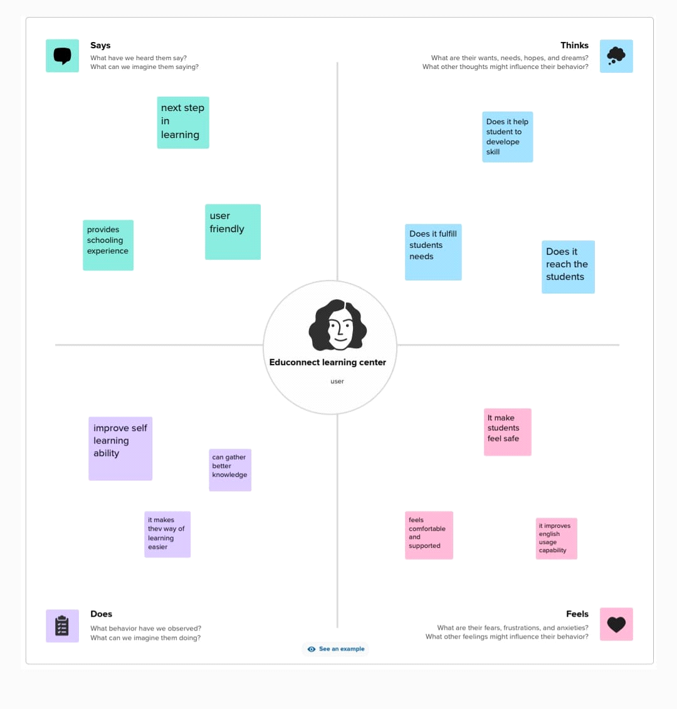

**2.2 IDEATION AND BRAINSTORMING**

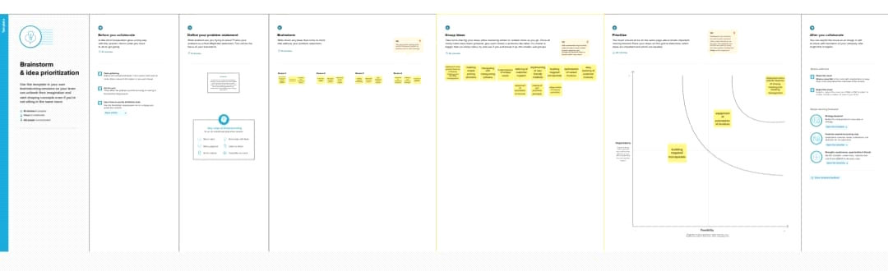

**3.RESULT**

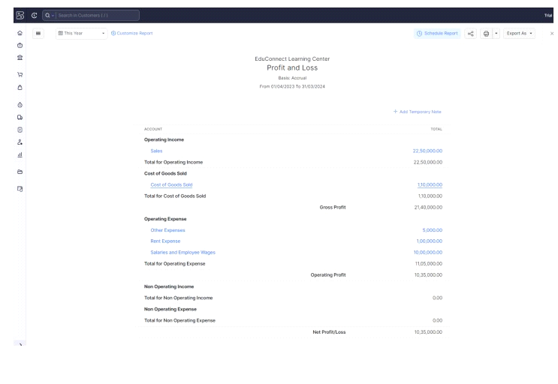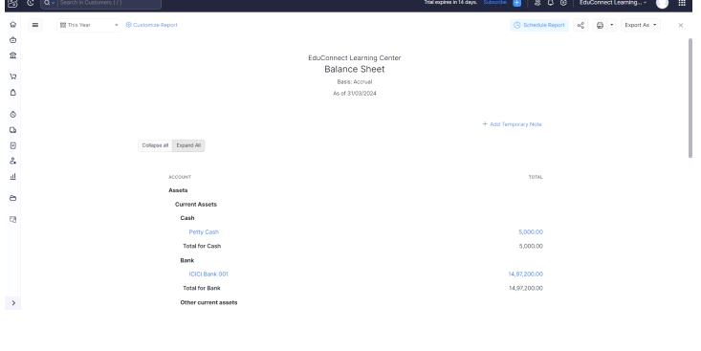

**4.ADVANTAGE & DISADVANTAGE**

**Advantages :**

**1. Automated workflows: Zoho Books simplifies the accounting processes at Educonnect Learning Center. The software automates repetitive tasks like invoicing and payment reminders, which saves time and increases productivity.**

**2.Security: Zoho Books is a secure software that ensures the safety of Educonnect Learning Center's financial data through its encryption protocols and regular data backups.**

**Disadvantages :**

**1.Customization limitations: Zoho Books has limited customization options, which may be a drawback for Educonnect Learning Center, as they may require specific customizations to manage their financials.**

**2.Reporting limitations: Zoho Books has limited reporting options as compared to other accounting software available in the market. This may be a drawback for Educonnect Learning Center, as they may require specific reports to analyze their financial data.**

**5.APPLICATIONS**

**Some of the potential applications of Zoho Books in Educonnect Learning center are:**

**1. Efficient Invoice Management: With Zoho Books, Educonnect Learning center can create and send professional-looking invoices to students or their parents with ease. The software allows for customization of invoice templates, automatic reminders, and online payment options that facilitate faster payments. In addition, the software can be integrated with third-party payment gateways, such as PayPal or Stripe, to accept payments from all major credit cards.**

**2. Expense Tracking: Educonnect Learning center can use Zoho Books to track all expenses related to running the center, including salaries, rent, equipment purchase, and other miscellaneous expenses. The software provides customizable expense categories and supports multiple currencies, making it easy to upload, categorize, and monitor expenses for effective budgeting.**

**6.CONCLUSION**

**To summarize the project done :**

**With the integration of Zoho Books, Educonnect Learning Center can maintain accurate financial records, automate their billing process, and streamline their financial operations. This enables them to focus on delivering quality education services to their students while managing their finances efficiently.**

**7.FUTURE SCOPE**

**1. Automating financial transactions: Zoho Books can help Educonnect automate its financial transactions, including invoicing, billing, and payment collection. This will save time and effort for the accounting team and improve the accuracy of financial data.**

**2.Monitoring cash flow: Zoho Books offers real-time updates and insights on cash flow. Educonnect can use this information to manage its cash flow more effectively, avoid late payments, and optimize business operations.**

**3.Integrating with other software: Zoho Books can integrate with other software used by Educonnect, such as learning management systems, payroll software, and CRM systems. This will provide a seamless experience for users and reduce the need for manual data entry.**